H.T No
Regulations:
A20

Sreenidhi Institute of Science and Technology
(An Autonomous Institution)
Code No: 8HC09 Date: 20-Sept-2024 (AN)

B.Tech I-Year I- Semester External Examination, Sept-2024 (Supplementary)
MATRIX METHODS AND CALCULAS(CIVIL,EEE,ME and ECE)

Time: 3 Hours Max.Marks:70

Note: a) No additional answer sheets will be provided.
b) All sub-parts of a question must be answered at one place only, otherwise it will not be valued.
c) Missing data can be assumed suitably.
Bloom's Cognitive Levels of Learning (BCLL)

Remember | L1 | Apply | L3 | Evaluate | L5
Understand | L2 | Analyze | L4 | Create | L6

Part - A Max.Marks:20

Answer all QUESTIONS.

 |  | BCLL | CO(s) | Marks
1 | Find the value of such that the rank of the matrix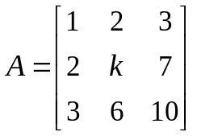is 2 | L2 | CO1 | [2M]
2 | Find the sum and product of the Eigen values of the matrix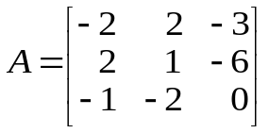 | L2 | CO2 | [2M]
3 | Write the formula for Fourier series expansion of even function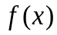in the  interval 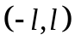 | L2 | CO3 | [2M]
4 | State Cauchy’s mean value theorem | L1 | CO4 | [2M]
5 | Evaluate 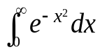 | L2 | CO5 | [2M]
6 | Show that the functions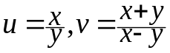are functionally related | L2 | CO6 | [2M]
7 | Find the Eigen values of the matrix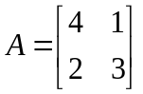 | L2 | CO2 | [2M]
8 | Find the value of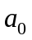in the half-range Fourier cosine series expansion of 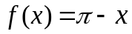in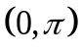 | L2 | CO3 | [2M]
9 | Define beta function | L2 | CO5 | [2M]
10 | If 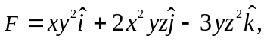 find 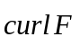at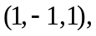 | L2 | CO4 | [2M]

Part – B Max.Marks:50
ANSWER ANY FIVE QUESTIONS. EACH QUESTION CARRIES 10 MARKS.

 |  |  | BCLL | CO(s) | Marks
11. | a) | Reduce the matrix 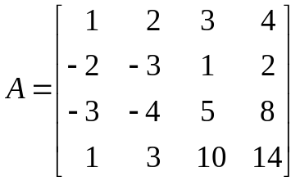into echelon form and hence find its rank | L2 | CO1 | [5M]
 | b) | Find the inverse of the matrix 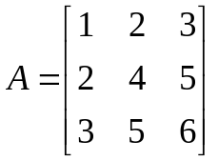by using Gauss-Jordan method. | L2 | CO1 | [5M]
12. |  | Find the Eigen values and corresponding Eigen vectors of the matrix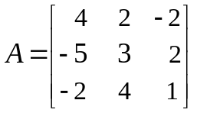 | L3 | CO2 | [5M]
13. |  | Find the Fourier series expansion of 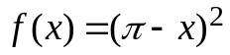in 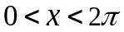 | L3 | CO3 | [5M]
14. |  | If 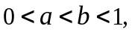 prove that 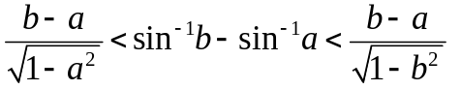and hence deduce that 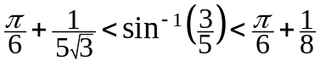 | L3 | CO4 | [5M]
15. | a) | Show that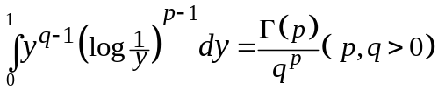 | L3 | CO5 | [5M]
 | b) | Find the volume of the solid generated by revolving the ellipse 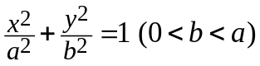about the major axis. | L3 | CO5 | [5M]
16. |  | A rectangular box open at the top is to have volume of 32 cubic ft. Find the dimensions of the box requiring least material for its construction. | L3 | CO6 | [10M]
17. | a) | Test for consistency | L3 | CO1 | [4M]
 | b) | Find the inverse of the matrix 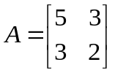by using Cayley-Hamilton theorem | L3 | CO2 | [3M]
 | c) | Express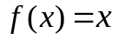as a half-range Fourier sine series in 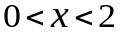 | L3 | CO3 | [3M]
18. | a) | Discuss the applicability of Rolle’s theorem for 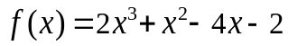in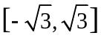 | L3 | CO5 | [4M]
 | b) | Show that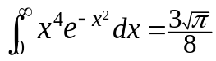 | L2 | CO6 | [3M]
 | c) | If 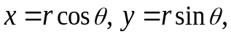evaluate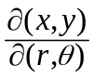 | L2 | CO6 | [3M]
-- 00 -- 00 –

